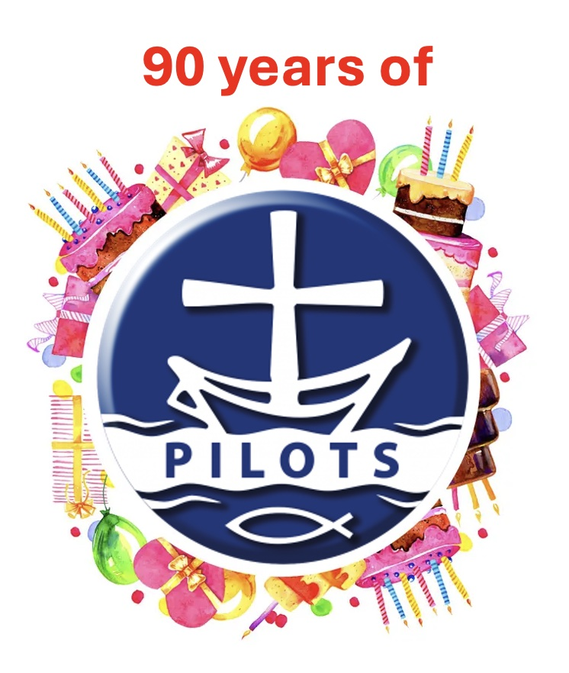
Split the Pilots in to teams with 3 or so in each team. Use the following questions about events over the last 90 years. The bonus question can be used if there is a tie.

Feel free to find your own additional questions.

Round 1: The War Years & The 1940s
1. Which global conflict, involving countries like Britain, Germany, and Japan, lasted from 1939 to 1945?
Answer: World War II.
2. Who was the British Prime Minister that gave the famous "We shall fight on the beaches" speech?
- Answer: Winston Churchill
- 3. In 1945, what was the name of the new international group formed to maintain world peace?
- Answer: The United Nations (UN).
4. In what year did India gain independence from British rule?
- Answer: 1947.

🚀 Round 2: Space & Technology
5. In 1969, who was the first person to walk on the moon?
- Answer: Neil Armstrong.
6. What "wall" divided a European city into East and West from 1961 to 1989?
- Answer: The Berlin Wall.
7. What huge invention, which now links computers all over the world, was invented by Tim Berners-Lee in 1989?
- Answer: The World Wide Web (Internet).
8. In what year did the Concorde aircraft, the fastest passenger plane, take its first flight?
- Answer: 1969.

🌍 Round 3: Modern Milestones (1990-2026)
9. Who became the first black President of South Africa in 1994, helping to end apartheid?
- Answer: Nelson Mandela.
10. What famous tunnel, opened in 1994, connects Britain and France underwater?
- Answer: The Eurostar "Chunnel".
11. In which year did the 29th Olympic Games take place in Beijing, China?
- Answer: 2008.
12. Which year marked the 50th anniversary of the first moon landing (2019)?
- Answer: 2019.

💡 Round 4: True or False
- 13. True or False: Queen Elizabeth II was crowned in 1953.
Answer: True.
14. True or False: The Titanic sank in 1990.
- Answer: False (It sank in 1912).
15. True or False: The first Harry Potter book was published in the 1990s (1997).
- Answer: True.

🏅 Bonus Question
What is the name of the pandemic that began in 2019-2020 and changed how people worked and went to school worldwide?
- Answer: COVID-19.

