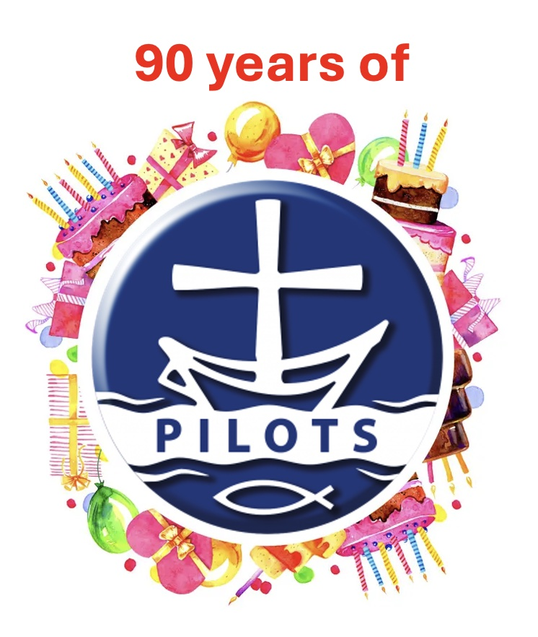
This worship idea was first published in the 75th anniversary pack

1990s Worship

This worship is adapted from the 1999 Pilots Sunday pack - Roots, Shoots and Froots.

The word ‘pilot’ or ‘pilots’ has different meanings and is used in different ways, such as ship’s pilot, aircraft pilot, pilot light, pilot project (ie. Experimental)

This is what each use means:
- A ship’s pilot is qualified to take charge of a ship entering or leaving a harbour.
- An aircraft pilot is qualified to take charge of the controls of the aircraft.
- A pilot light is always alight and ready to light another flame.
- A pilot project is an experiment that may lead to something bigger.

All these uses or the word ‘pilot’ or ‘pilots’ have something in common. A pilot shows the way … is a guide … a leader.

We are all called to be pilots, because we’re asked by God to show others the way, to guide them and to lead them towards a friendship with Jesus. That’s what Jesus meant when he told his friends to, ‘Go … to all people’s everywhere and make them my disciples …’ (Matthew 28:19)

Because we are God’s pilots, and because Jesus is our Master Pilot, we can make a difference, in our lives, in our church and in our local communities, we can guide and lead the way. All we need to remember is that Jesus is the ‘Why’ and the ‘How’.

Prayer

Oh Jesus
We commit ourselves to be your pilots showing the way,
guiding and leading others to you, so that they might become your friend.
You are our Master Pilot, always watching over us,
Coming to us again and again, to help us and encourage us.
Show us how to be faithful pilots in all we do and say.
Amen.

