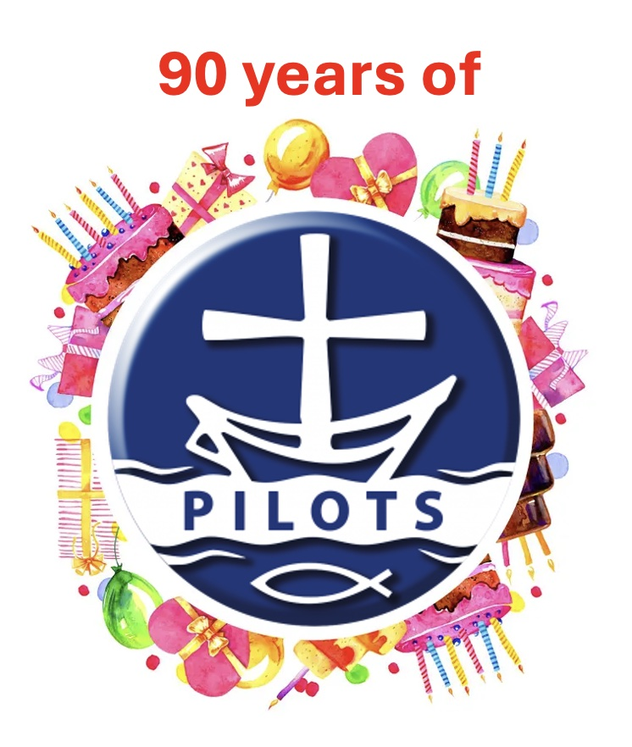
Hold a 1936 evening

As with the birthday party idea, you will need to decide the following:

- Will it be for your current Pilots, or will you invite others, such as former Pilots or church members.
- Will you have food? If you do, will you try to use food from 1936?
- Will you play games? If so, use some from 1936.
- Will you come in 1936 clothing?
- You could have a quiz on significant events of 1936 (see quiz section).

Take photos and share the story of your celebrations on the Pilots Facebook page and the Pilots website.

