A man was travelling from Jerusalem to Jericho. As he walked, he was attacked by robbers. They stripped him of his clothes, beat him severely, and left him very badly injured at the side of the road.
A while later, a priest happened to be going down the same road. He saw the injured man and crossed over to the other side of the street. He walked away without offering the man any help. A little later, another religious leader also walked down the same road. Like the priest, he saw the injured man but made no effort to come to his aid. The leader carried on walking, leaving the man by the side of the road.
But then, a Samaritan walked down the road.
At the time of the story, Jews and Samaritans did not get along and would have nothing to do with each other.
Samaritan saw the injured Jewish man lying in the road. Unlike the priest and the Levite, he stopped and took pity on the man. He bent down and bandaged the man’s wounds, pouring on oil and wine. He helped the man climb up onto the back of his own donkey and then took him to an inn, walking alongside the donkey.
Jesus turned back to the expert in the law. “Which of the three men was a neighbour to the injured man?” he asked.
“The man who helped,” said the expert in the law.
“Go and do the same,” said Jesus.
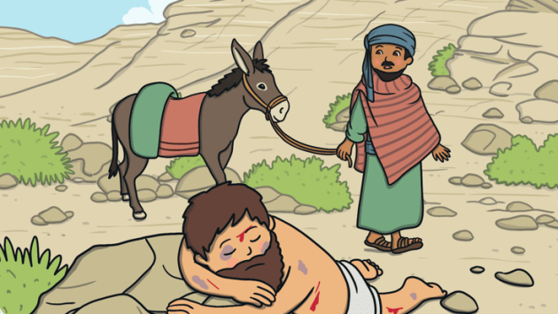

Zaccheus was a tax collector in Jericho, what is known today as Tell es-Sultan in Palestine. He was renowned for cheating people out of their money and was a rich but unpopular member of the community.
One day, Zacchaeus was excited to hear that Jesus was visiting the town. He wanted to see who Jesus was, and he decided to join the crowd of people who were also gathering to see him. The town was very busy, and Zacchaeus was too short to be able to see Jesus over the top of all the people.
Zacchaeus had the idea to run ahead of the crowd and climbed a sycamore tree to get a better view of Jesus. As Jesus passed by, he looked up and called out to Zacchaeus. “Zacchaeus, hurry down. I am coming to your house for tea.”
Zacchaeus was delighted that Jesus was visiting his home, but the people in the town were surprised and angry with Jesus for spending time with a sinful man.
Having Jesus as his guest made Zacchaeus think about his greedy ways, and he had a change of heart. He declared, "Look, Lord. I will give half of my wealth to the poor people. I will also pay back four times the amount of money to people I have cheated."
Jesus was pleased that he had helped Zacchaeus to change his ways. From that day on, Zacchaeus lead his life as a kind person that was popular with his neighbours.
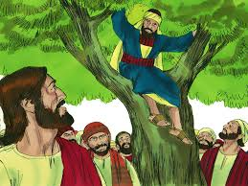

And they came to Jericho. And as he was leaving Jericho with his disciples and a great crowd, Bartimaeus, a blind beggar, the son of Timaeus, was sitting by the roadside. And when he heard that it was Jesus of Nazareth, he began to cry out and say, "Jesus, Son of David, have mercy on me!" And many rebuked him, telling him to be silent. But he cried out all the more, "Son of David, have mercy on me!" And Jesus stopped and said, "Call him." And they called the blind man, saying to him, "Take heart. Get up; he is calling you." And throwing off his cloak, he sprang up and came to Jesus. And Jesus said to him, "What do you want me to do for you?" And the blind man said to him, "Rabbi, let me recover my sight." And Jesus said to him, "Go your way; your faith has made you well." And immediately he recovered his sight and followed him on the way.

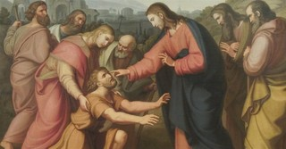

Give out jelly babies – why did you pick that one – the flavour, the colour or because he seemed to be smiling
They are all different but they all come from the same packet. That’s like us – we are all different but we all come from the same God.
But probably about half or more of the people on the earth would be quite right to say “IT’S NOT FAIR!!”
Last Sunday was the Day for Racial Justice when we were asked to pray for all the people in the world who suffer from discrimination. That’s a big word but it means that some people are treated differently because of who are what they are.
So what makes people different?
Coming from another country
Religion
Colour of skin
Language
Disability
Wealth
And some people are unkind for no reason at all. Therse are called BULLIES.
Jesus came to show us that God created us all equal and we should treat everyone like he did. It’s not easy – if you don’t like someone just leave them alone – don’t make yourself into someone Jesus wouldn’t agree with. He would still love you but expect you to love ALL the people you meet.

Prayer
- A Prayer for Fairness: "Lord, We feel sad about unfair things happening in the world. Please protect people who are hurting, bring peace where there is trouble, and help us make things right, help us to be brave when we see something unfair and give us the strength to stand up for them, even if we are scared. Amen."

- Jesus, help me to see people the way you see them—as special and loved. Teach me to love and treat everyone fairly, and show me how to be a good friend. Amen."

